CSA0502 – QUERY PROCESSING FOR DATASCIENCE
Lab Programs

- Select the distinct department IDs from the employees file

Code:
import pandas as pd

# Dataset
data = {
"EmpID": [101, 102, 103, 104, 105, 106],
"Name": ["Alice", "Bob", "Charlie", "David", "Eva", "John"],
"DepartmentID": [10, 20, 10, 30, 20, 40]
}

df = pd.DataFrame(data)

print("Employees Data:")
print(df)

print("\nDistinct Department IDs:")
print(df["DepartmentID"].unique())
OUTPUT:
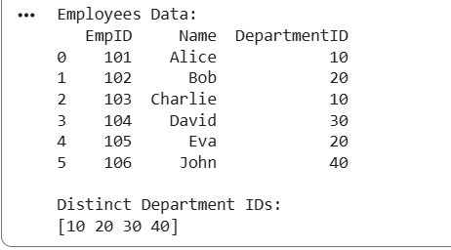
2. Display the IDs of employees who have done two or more jobs
CODE:
import pandas as pd

# Dataset
data = {
"EmpID": [101, 101, 102, 103, 103, 103, 104],
"Job": ["Manager", "Clerk", "Analyst", "Sales", "HR", "Manager", "Clerk"]
}

df = pd.DataFrame(data)

print("Employee Jobs:")
print(df)

# Employees having two or more jobs
result = df.groupby("EmpID").size()

print("\nEmployees with Two or More Jobs:")
print(result[result >= 2])

OUTPUT:
